**MoU Signed with DePaul Arts and Science College, Edathotty**

Activities conducted:

* Conducted a Student and Teacher exchange program for the final year students of B.Sc. Computer Science, Mahatma Gandhi College Iritty and BCA students of DePaul Arts and Science College Edathotty.
* Rev. Dr. Peter Ooroth handled the session on AI Tools for Web Development and Dr. Reshma P K handled the session on How AI is shaping the future. 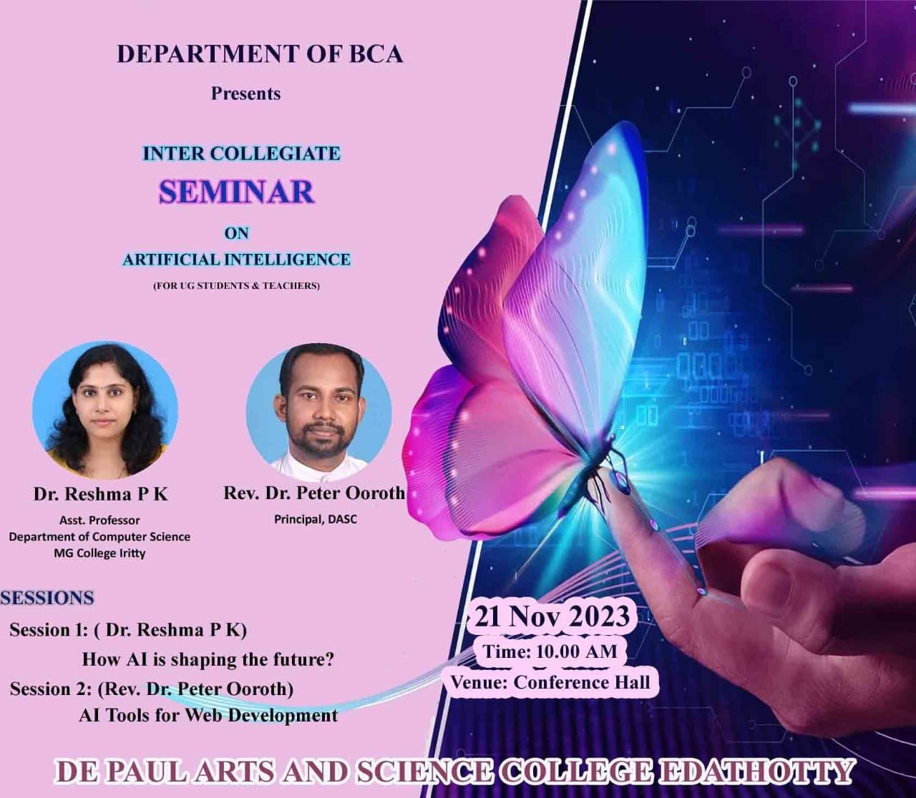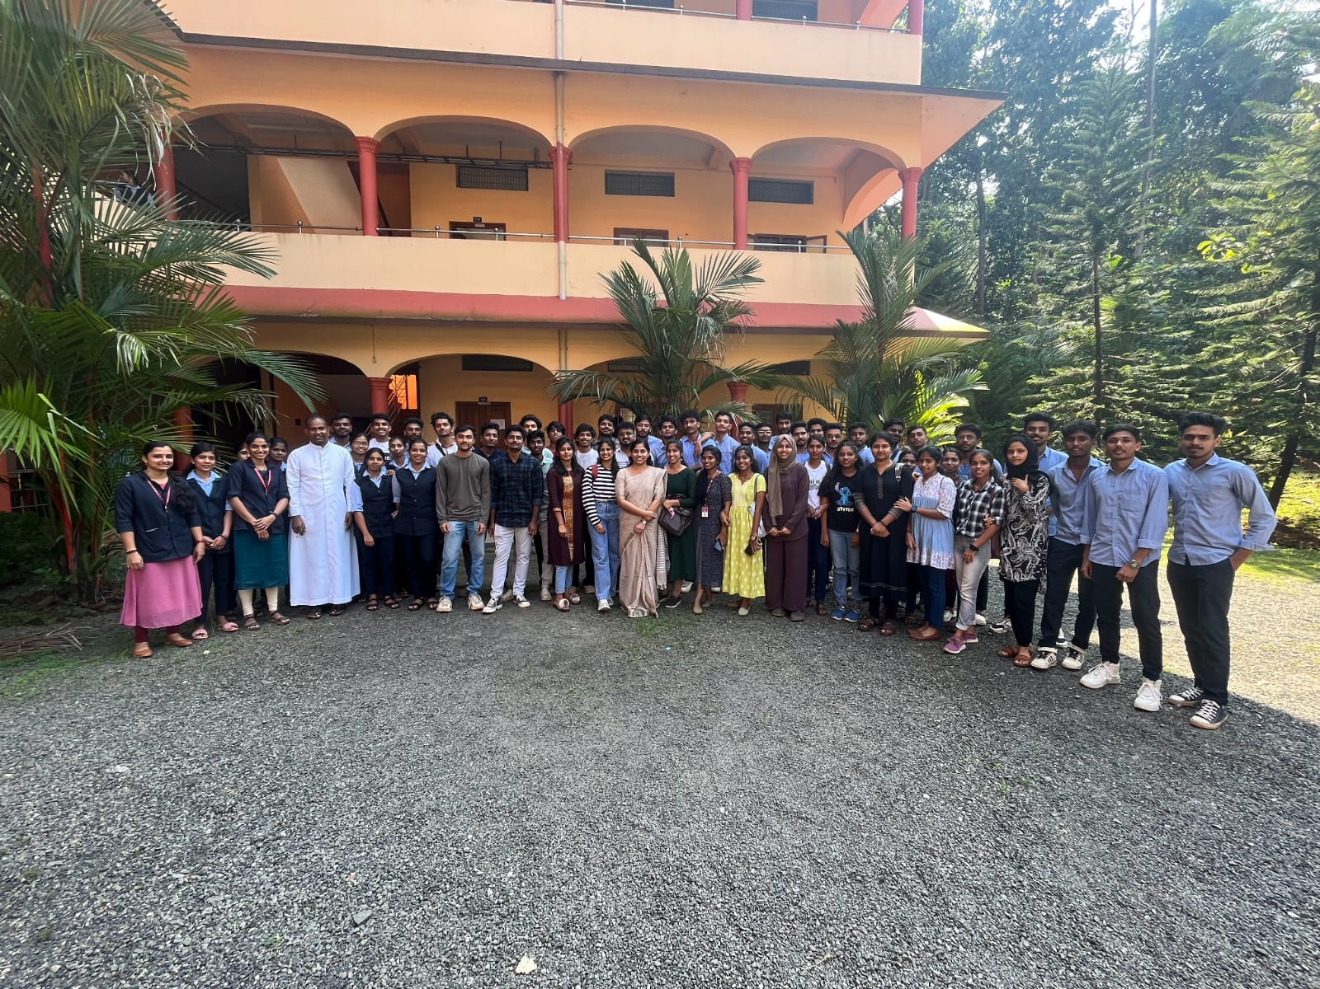
* 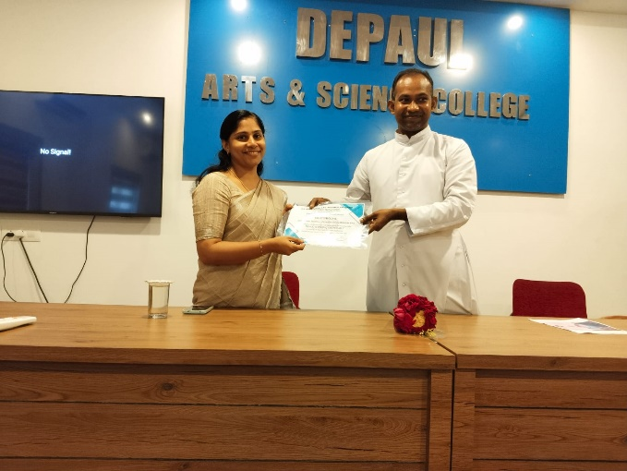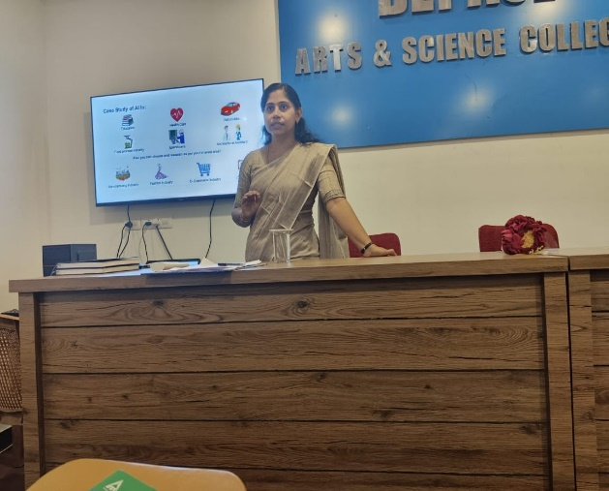
* Conducted a seminar on Research Methodology

