Career Guidance & placement cell in association with IQAC organised a seminar on the topic “Changing Opportunities in Higher Education and Career”. Dr. T. P Sethumadhavan, Professor Transdisciplinary University of Health Science & Technology, Bengaluru delivered the talk on 03.08.2023.

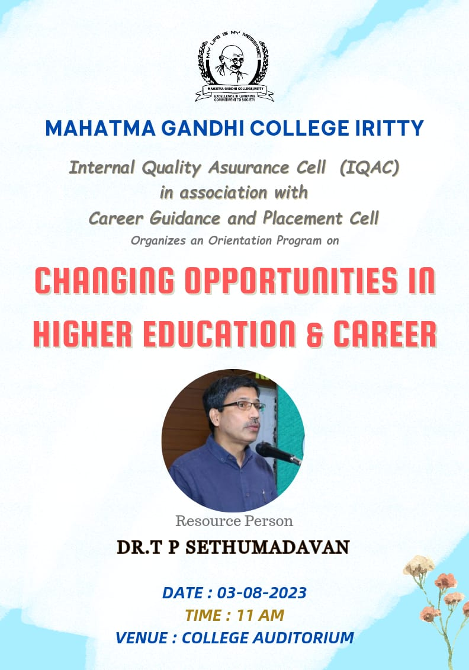

<https://youtu.be/3OKEBC55-h4>

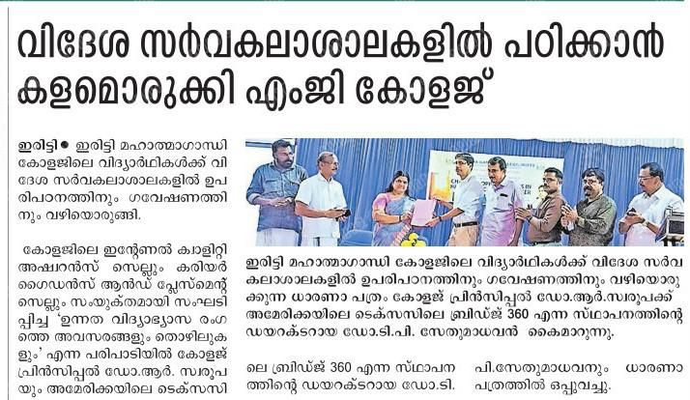<https://youtu.be/HeDL1X0wXrQ>