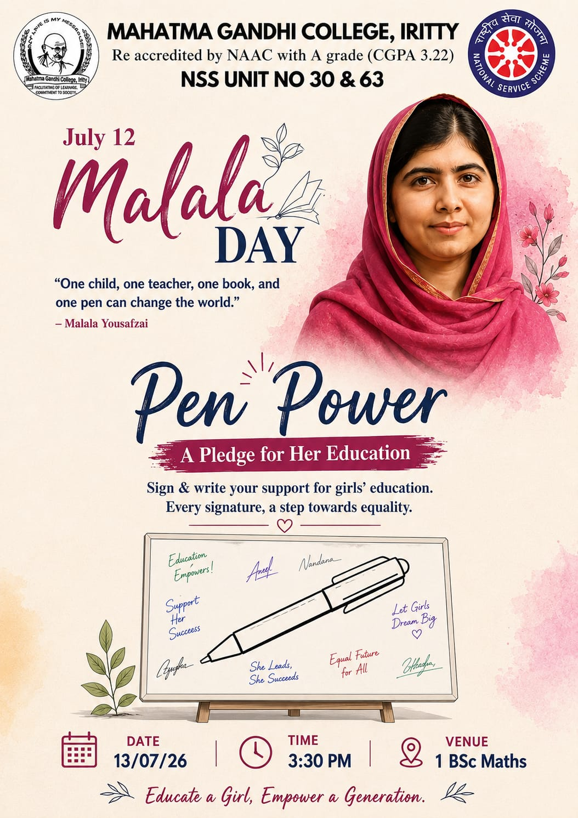
MAHATMA GANDHI COLLEGE,
IRITTY
NATIONAL SERVICE SCHEME UNIT
NO. 30 & 63

National service scheme (nss) event Report
Name of the event: Pen Power: A Pledge For Her Education (Malala Day Observance)
Organized by NSS Units 30 & 63, MG
College, Iritty
Date of the Event:13th July 2026
Time:03:30 PM
Venue 1 BSc Mathematics Classroom
Theme / Slogan “Educate a Girl, Empower a Generation.“

Introduction
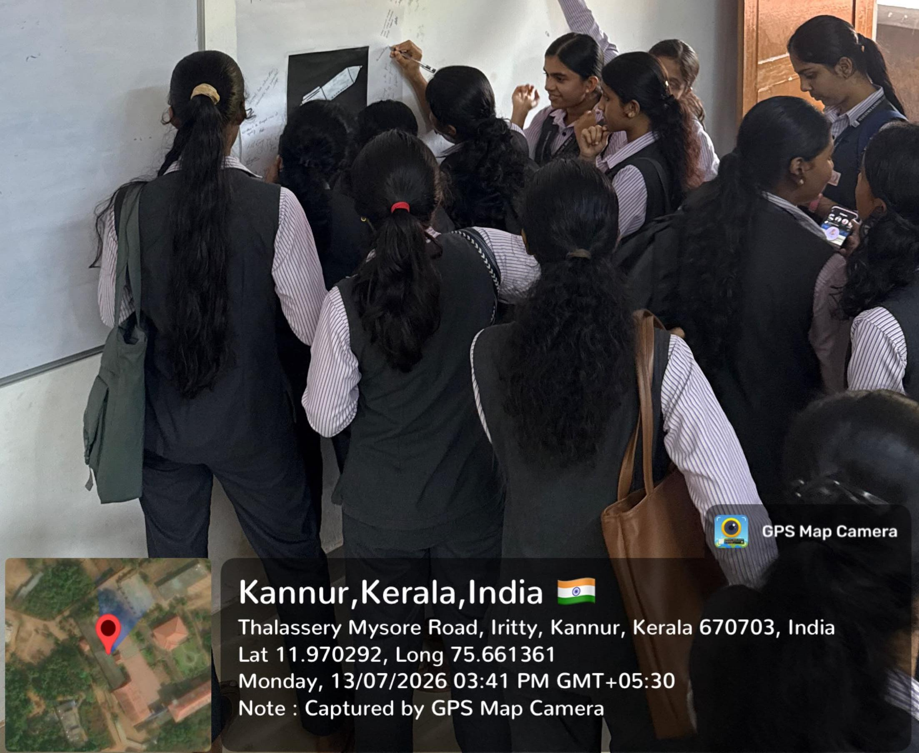
In connection with International Malala Day, which is observed globally on Jul y 12, the National Service Scheme ( N SS) Units 30 & 63 of Mahatma Gandhi College, Iritty, organized a special commemorative and signature campaign programme titled "Pen Power : A Pledge for Her Education". The event was held on 13th July 2026 at 03:30 PM in the 1 BSc Mathematics classroom. The primary objective of the programme was to raise awareness about the critical importance of girls' education and gender equality, as well as to honor the inspiring legacy of the youngest Nobel Prize laureate, Malala Yousafzai.

Event Highlights
The event commenced with an introductory address Highlighting Malala Yousafzai’s famous and impactful Quote: “One child, one teacher , one book, and one pen Can change the world. “The student coordinator symphasized the ongoing global challenges faced by Girls in accessing quality Education and highlighted the necessity of active youth Intervention in promoting equal academic and social Opportunities .The core highlight of the programme was the Signature And Pledge Campaign. A beautifully designed white Board featuring a symbolic pen illustration was set up, Where volunteer s and students gathered to sign and Write short messages of solidarity supporting female Empowerment and educational rights .
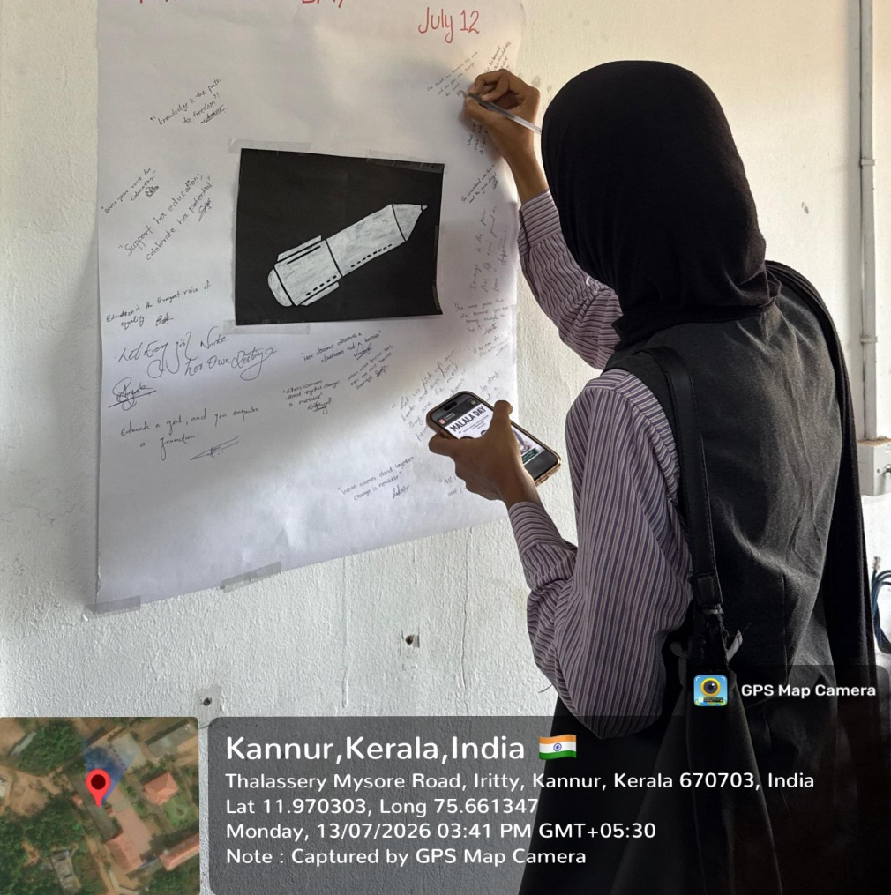

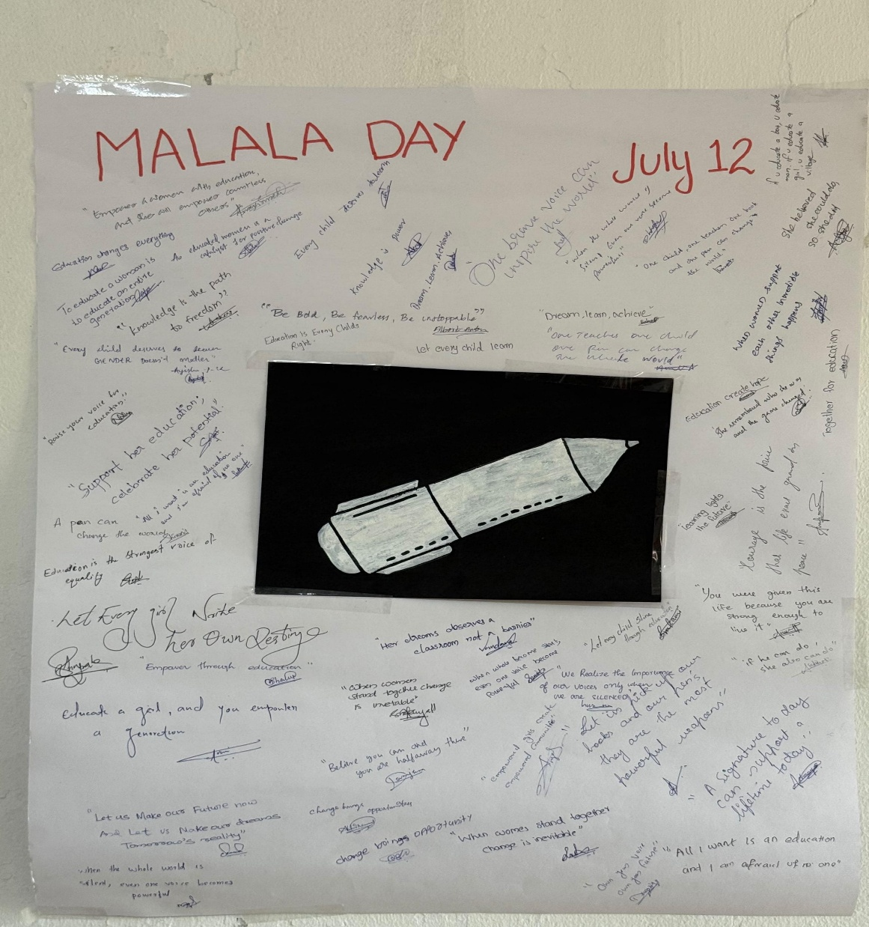
h “en Power “ campaign proved that a single Signature can represent a massive step toward Change. By coming together to pledge their Support t , the students and faculty of Mahatma Gandhi College transformed Malala Yousafzai’s Legacy from a distant global ideal into an active, Local commitment . Ultimately, the event served as A powerful reminder that educating and Empowering girls is not just a female issue—It is a Shared responsibility that shapes a better future For everyone.

Report Prepared By:
N SS Volunteer
N SS Unit 30 & 63
N SS G R O U P N O : 7
Mahatma Gandhi College,
Iritty

